LIBRARY DESK
Java Object-Oriented Programming Project Documentation
Course: Object-Oriented Programming
Group members: ______________________________________________
Section: ____________________ Instructor: ____________________
Submission date: ____________________
Java Swing desktop library-management application

1. Project Title
Library Desk

2. Project Description
Library Desk is a desktop library-management application developed in Java using Swing. It gives library staff a graphical way to manage a book catalog and member directory, issue books, record returns, and review circulation activity. It validates library rules before saving and stores data locally so it remains available after restart.

3. Problem Statement
Small libraries need reliable records of books, readers, available copies, and borrowing history. Paper-based or fragmented tracking can cause inaccurate inventory, missed due dates, duplicate records, or invalid checkouts. Library Desk centralizes these tasks and validates operations to help staff maintain consistent catalog and circulation records.

4. Objectives
• Apply Java OOP concepts to a real-world library-management problem.
• Design multiple classes with clear responsibilities and relationships.
• Demonstrate encapsulation, inheritance, polymorphism, and abstraction in working code.
• Provide a usable Java Swing GUI for major library tasks.
• Validate input and reject invalid or disallowed transactions with clear feedback.
• Persist library records and test key business rules.

5. System Features
• Dashboard with book, available-copy, active-member, active-loan, and overdue-loan metrics.
• Book catalog: add, view, search, update, and delete books.
• Member directory: add, view, search, update, activate/deactivate, and remove members.
• Circulation: check out available books to active members and record returns.
• Loan history with checkout date, due date, returned status, and overdue status.
• Automatic due dates set 14 days after checkout.
• Local persistence using atomic file replacement.
• Business rules prevent duplicate ISBN/email, unavailable/inactive checkouts, more than three active loans per member, and removal of members with active loans; history is retained for returned loans.

6. OOP Implementation
The application is organized into domain, service, storage, and Swing UI classes. The four required OOP pillars are demonstrated as follows:
Encapsulation

LibraryRecord, Book, Member, and Loan keep state in private fields. Getters and controlled operations such as checkOutCopy(), returnCopy(), setActive(), and markReturned() manage state. LibraryService returns detached copies so callers cannot mutate its stored records directly. Examples: Book.java, Member.java, Loan.java, LibraryRecord.java, and LibraryService.java.
Inheritance

Abstract LibraryRecord is the parent of Book, Member, and Loan. The subclasses share record identity and creation time while adding their own fields and behaviors. Examples: LibraryRecord.java, Book.java, Member.java, and Loan.java.
Polymorphism

Book, Member, and Loan override getDisplayName(). LibraryRecord.toString() calls the override on the runtime subtype, and LibraryService.getRecords() returns different record types through List<LibraryRecord>. Examples: LibraryRecord.java, Book.java, Member.java, Loan.java, and LibraryService.java.
Abstraction

LibraryRecord is an abstract class defining shared identity and display behavior. LibraryRepository is an interface hiding persistence details from LibraryService; FileLibraryRepository implements local file storage. Examples: LibraryRecord.java, LibraryRepository.java, FileLibraryRepository.java, and LibraryService.java.
Class responsibilities

domain: LibraryRecord, Book, Member, Loan — entities and state. service: LibraryService, LibraryException — validation, business rules, transactions. storage: LibraryRepository, FileLibraryRepository, LibraryDataStore — local persistence. ui: LibraryAppFrame, DashboardPanel, BooksPanel, MembersPanel, LoansPanel, Theme, UiSupport — Swing screens and controls. Main initializes storage and launches the app.

7. UML Class Diagram
This diagram summarizes the principal implemented classes and relationships. UML visibility symbols: + public, - private, # protected, ~ package-private. The following class specifications document key attributes, methods, and relationships.
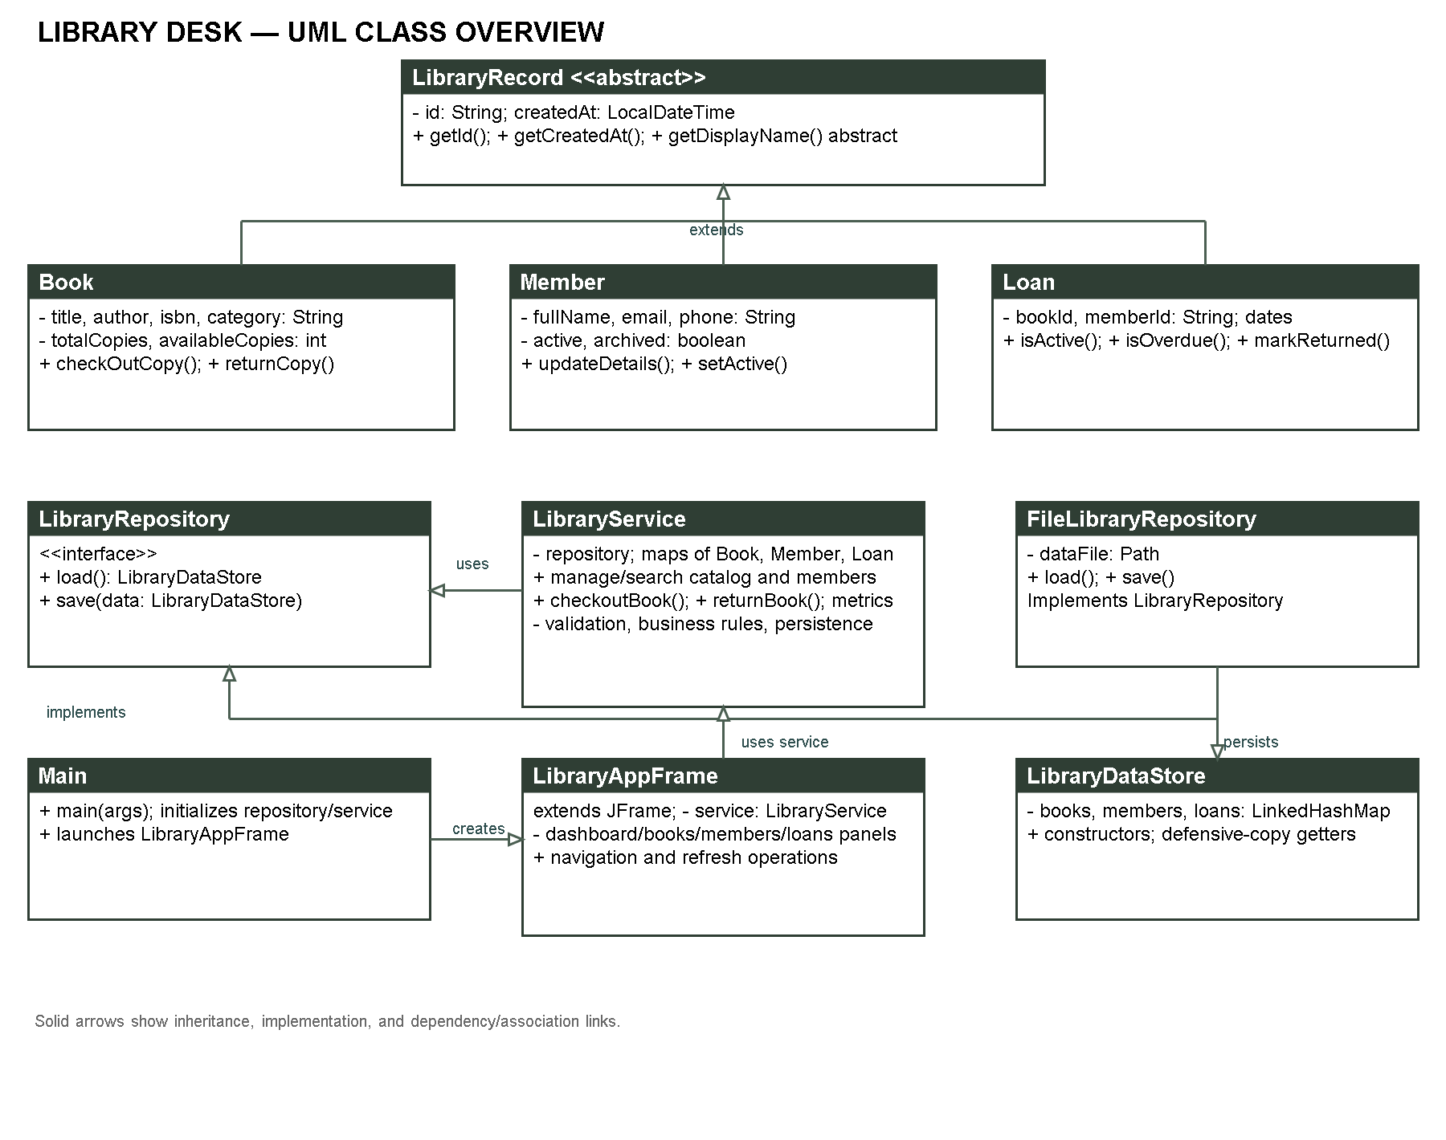
Figure 1. Library Desk UML class and relationship overview.

LibraryRecord (abstract): -id: String; -createdAt: LocalDateTime. #constructors; +getId(); +getCreatedAt(); +getDisplayName() abstract; +toString(); +equals(); +hashCode(). Parent of Book, Member, and Loan.
Book: -title, author, isbn, category: String; -totalCopies, availableCopies: int. +constructors; +copy(); +getters; +getCheckedOutCopies(); +updateDetails(); +checkOutCopy(); +returnCopy(); +getDisplayName(). Extends LibraryRecord; referenced by Loan; held in LibraryService and LibraryDataStore.
Member: -fullName, email, phone: String; -active, archived: boolean. +constructors; +copy(); +getters; +updateDetails(); +setActive(); +archive(); +getDisplayName(). Extends LibraryRecord; referenced by Loan; held in LibraryService and LibraryDataStore.
Loan: -bookId, memberId: String; -checkoutDate, dueDate, returnedDate: LocalDate. +constructors; +copy(); +getters; +isActive(); +isOverdue(); +markReturned(); +getDisplayName(). Extends LibraryRecord; associates one Book and Member by IDs.
LibraryService: -repository: LibraryRepository; -maps of Book, Member, Loan; -validation patterns and loan limit. +list/search/get/add/update/delete books and members; +checkoutBook(); +returnBook(); +dashboard metrics; -validateBook(); -validateMember(); -persist(). Uses repository and data store; manages domain records.
LibraryRepository (interface): +load(): LibraryDataStore; +save(data): void. Implemented by FileLibraryRepository and used by LibraryService.
FileLibraryRepository: -dataFile: Path; +constructor(Path); +load(); +save(). Implements LibraryRepository and serializes LibraryDataStore.
LibraryDataStore: -books, members, loans: LinkedHashMap<String, entity>; +constructors; +getBooks(); +getMembers(); +getLoans(). Contains the persistent record collections.
LibraryAppFrame: -service: LibraryService; -DashboardPanel, BooksPanel, MembersPanel, LoansPanel. +constructor(service); -navigation and refresh operations. Extends JFrame, composes screens, and calls the service.
DashboardPanel, BooksPanel, MembersPanel, LoansPanel: each extends JPanel and uses LibraryService. Each has package-private construction and refresh operations; panel classes also hold controls, table models, and callbacks. BooksPanel and MembersPanel use SearchField.
Main: +main(args); -launch(). Creates the repository and service and displays the frame. LibraryException extends Exception and provides message/cause constructors for surfaced service errors.
Theme and UiSupport provide package-private visual, validation-feedback, and date-formatting helpers. SearchField extends JTextField and displays the accessible search prompt.

8. GUI Screenshots
The following screenshots document the major application views.
The demonstration catalog contains four titles (10 copies total): Effective Java, Head First Java, Java Swing, and Object-Oriented Thought Process. The catalog screenshot shows all four. The Java search screenshot intentionally shows only the three matching titles; its “3 matching books” count is the filtered result count, not the total catalog size.
The sample library also includes two active members, Jordan Lee and Casey Morgan, and three loan-history records: Head First Java for Jordan Lee (returned), Effective Java for Jordan Lee (on loan), and Java Swing for Casey Morgan (on loan). The dashboard therefore shows four titles, eight available copies, two active members, two active loans, and zero overdue loans; its recent-activity list contains the three loan records.
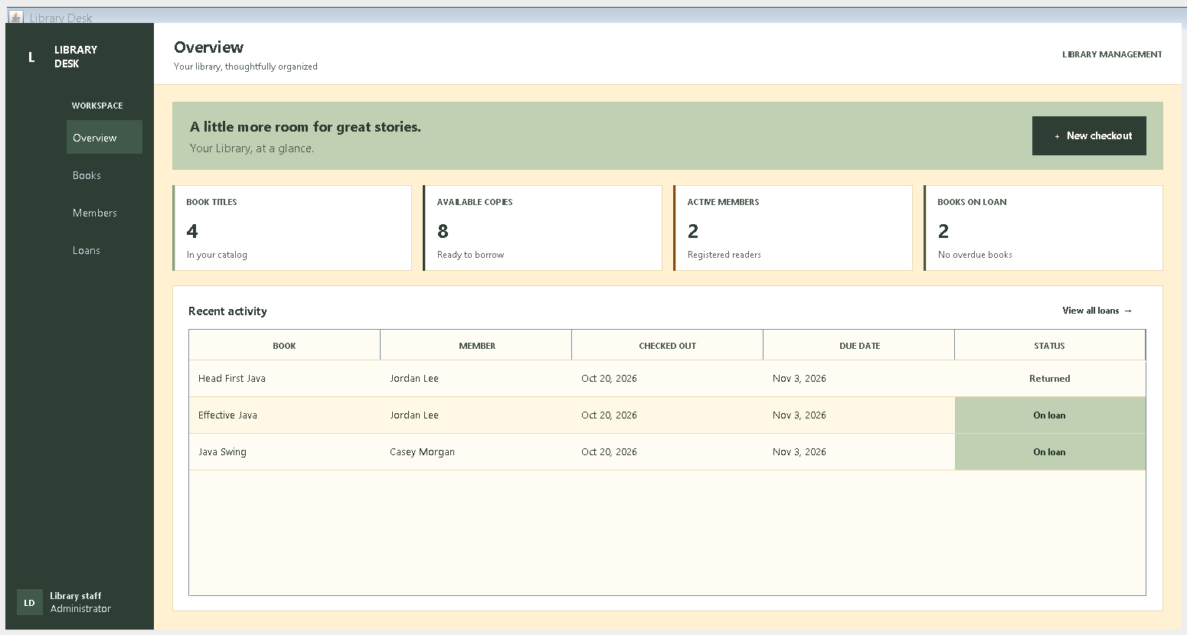
Figure 2. Dashboard overview with library metrics and navigation.
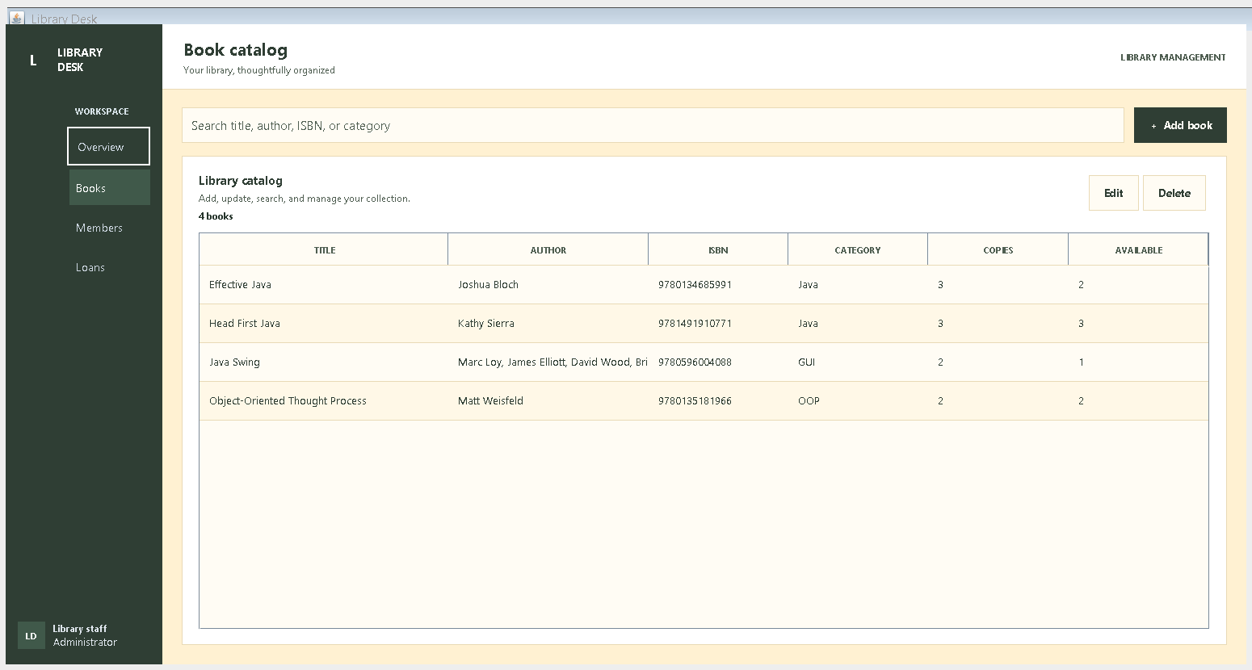
Figure 3. Searchable book catalog and book-management controls.
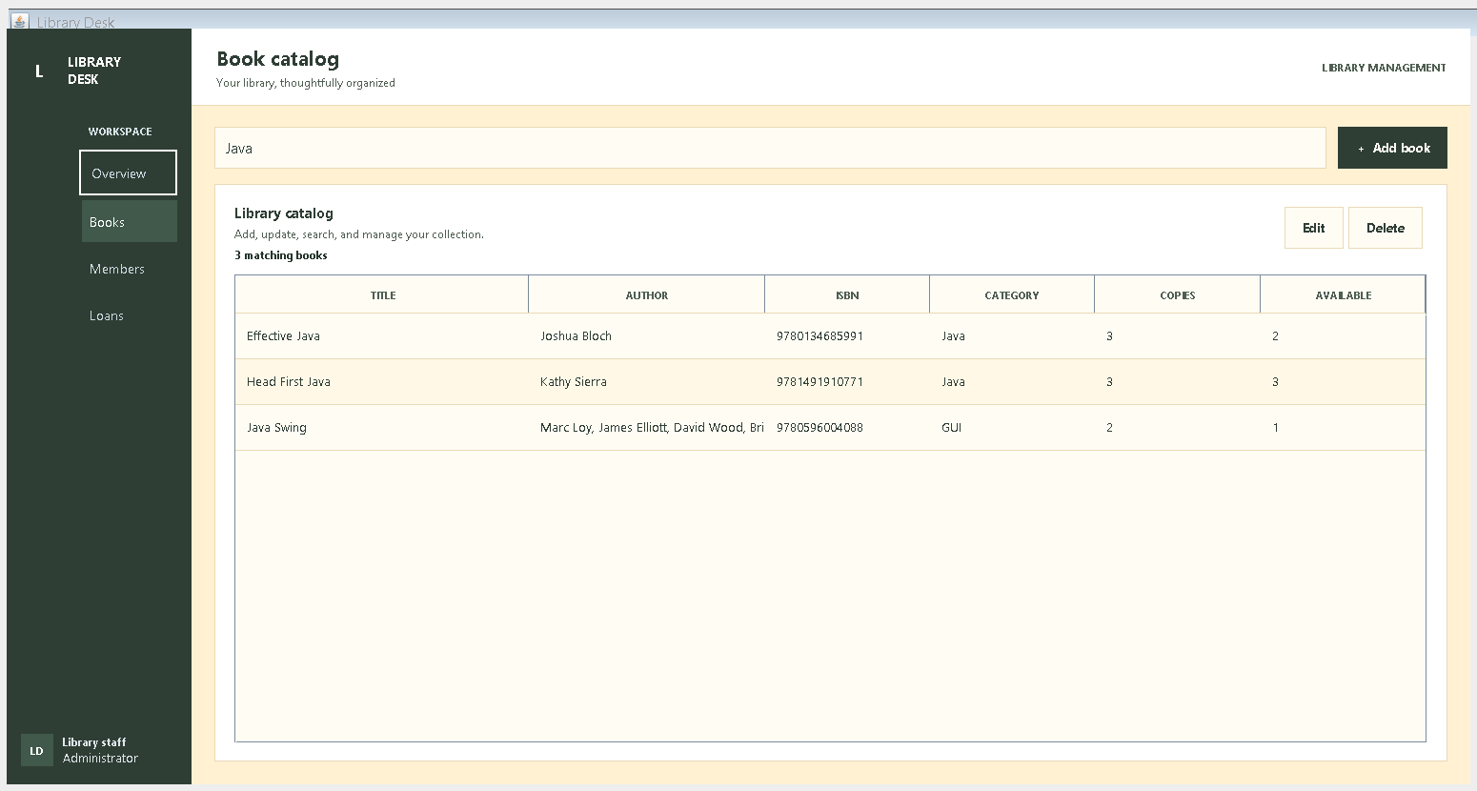
Figure 4. Book search results filtered to Java.
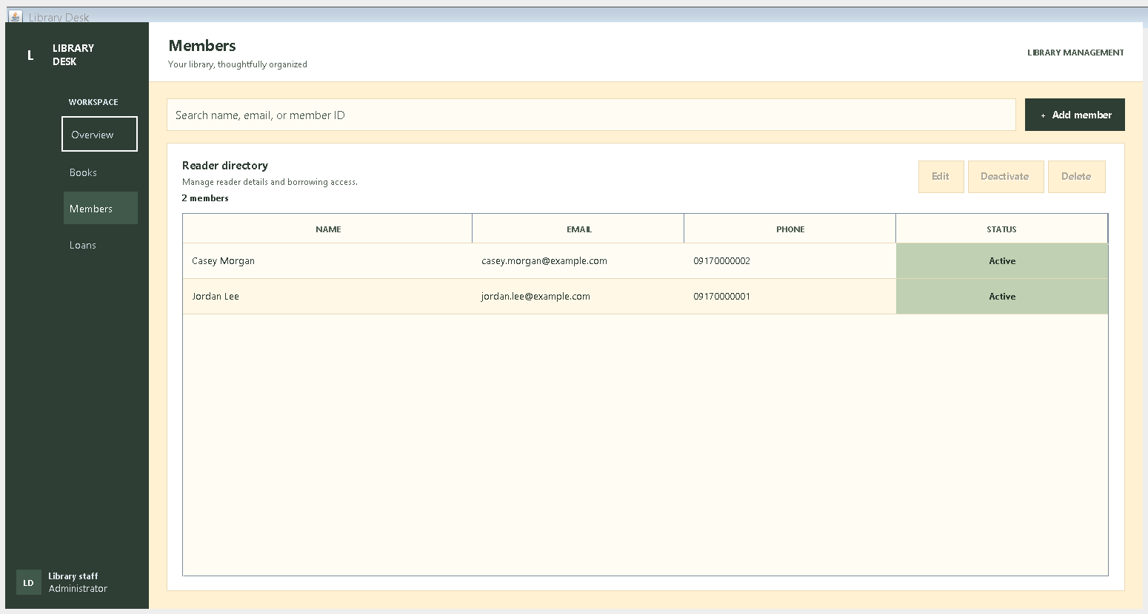
Figure 5. Member directory with the sample readers.
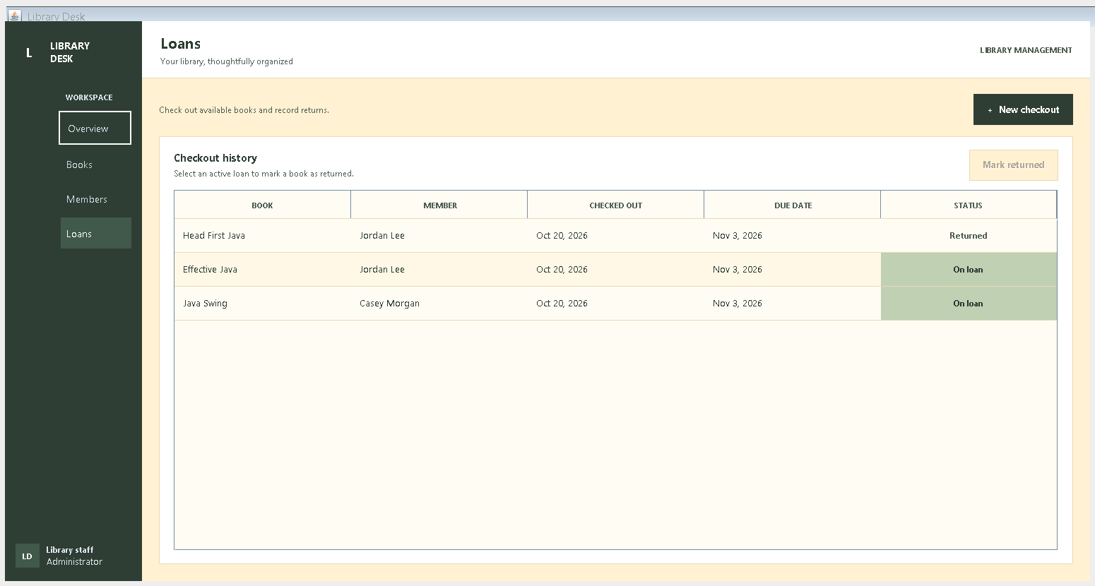
Figure 6. Loan history with active and returned sample loans.

9. Testing
The dependency-free test runners were executed after compiling all production and test sources. Both passed.
LibraryServiceTest — PASSED. Exercises required fields and formats; duplicate ISBN/email; catalog/member operations; checkout limits and eligibility; copy counts and returns; member archival; search; persisted state after reopening; defensive copies; and persistence failure without changing service state.
LibraryUiDesignTest — PASSED. Verifies 12 foreground/background text combinations against the 4.5:1 WCAG AA normal-text contrast threshold and checks primary-button rendering.
To reproduce from the project root in PowerShell, compile all Java files under src and run: java -ea -cp out com.folio.library.service.LibraryServiceTest and java -ea -cp out com.folio.library.ui.LibraryUiDesignTest.

10. Conclusion
Library Desk applies Java object-oriented design to a practical library system. Encapsulated domain objects, an abstract record hierarchy, polymorphic record behavior, and a repository abstraction support a Swing application whose service layer validates library operations and persists changes. Automated tests provide repeatable evidence for key business rules and GUI contrast checks. During the final presentation, the group should explain these implementations and demonstrate book and member management, checkout, returns, input validation, and persistence.

